Project Title : Big Data Analytics For Business Insight
Team ID : SIC-25-26-Team410
Date : 16-Feb-2026

1. Introduction & Objective
* The primary goal of this project is to analyze product sales data to identify key business trends.
* We aim to provide insights into sales distribution and product performance using data science tools.

2. Tools & Technology Used
* Python : For data manipulation and analysis.
* Google Colab : As the primary environment for running Python scripts.
* GitHub : For version control and project documentation.
* Pandas & Seaborn :For data cleaning and visualization.

3. Data Analysis Process
* Data Acquisition : The dataset file.csv was uploaded to the data/ folder.
* Data Cleaning : We verified the data for missing (null) values using code. The dataset was found to be of high quality with no significant errors.
* Exploratory Data Analysis (EDA) : Performed statistical checks and visualized trends.
4. Visual Insights (Graphs) <<<<<<<<<<<<<<<<<<<>>>><<

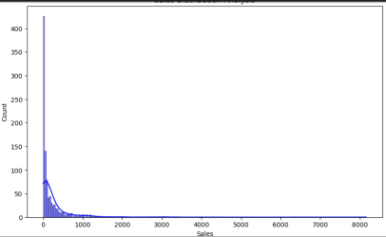
- Sales Distribution Analysis
The chart above represents the distribution of sales across different categories.
* It helps identify which products are generating the most revenue.

5. Conclusion
* The project successfully demonstrates how Big Data tools can be used to gain business insights from raw data.

---

